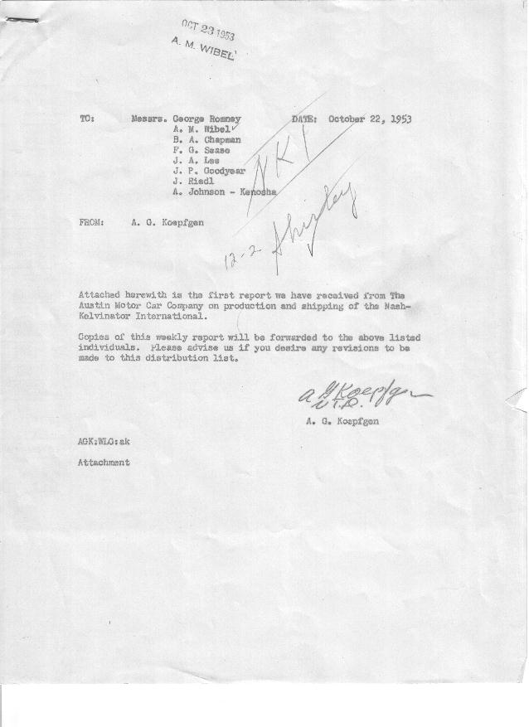

FORM NO. PLAN 11, 8-53 NKP NKI SERIES CARS PRINTED IN U.S.A.
AUSTIN MOTORS CO., LTD., ENGLAND
WEEKLY PERFORMANCE REPORT
WEEK ENDING 11TH OCTOBER, 1953 .
 | ASSEMBLED |  | SHIPPED (TURNED OVER TO SHIPPING AGENT) With “On Board” Bill of Lading |  |  |  |  |  |  |  |  |  |  |  |  |  |  |  |  |  |  |  |  |  |  |  |  |  |  |  | ON  HAND
MODEL | WK.  TOTAL | CUM’L  TOTAL | CHARLESTON |  | BALTIMORE |  | HOUSTON |  | LOS ANGELES |  | NEW ORL’NS |  | PHILA. |  | SAN FRAN. |  | SAVANNAH |  | SEATTLE |  | HALIFAX |  | VANCOUVER |  | BOSTON |  | NEW YORK |  | ALL PORTS
MODEL | WK.  TOTAL | CUM’L  TOTAL | WK. | CUM’L | WK. | CUM’L | WK. | CUM’L | WK. | CUM’L | WK | CUM’L | WK. | CUM’L | WK. | CUM’L | WK. | CUM’L | WK. | CUM’L | WK. | CUM’L | WK. | CUM’L | WK. | CUM’L | WK. | CUM’L | WK | CUM’L
SOFT-TOP

P-904-B BSW
“ WSW
P-905-B BSW
“ WSW
P-906-B BSW
“ WSW
P-903-L BSW
“ WSW
P-905-L BSW
“ WSW
TOTAL  HARD-TOP  P-903-7 BSW  GREEN WSW | 20 | 20 |  |  |  |  |  |  |  |  |  |  |  |  |  |  |  |  |  |  |  |  |  |  |  |  |  |  |  |  | 20
P-904-7 BSW
BLUE WSW
P-905-7 BSW
RED WSW
P-906-7 BSW
YELLOW WSW
TOTAL | 20 | 20 |  |  |  |  |  |  |  |  |  |  |  |  |  |  |  |  |  |  |  |  |  |  |  |  |  |  |  |  | 20
GRAND TOTAL | 20 | 20 |  |  |  |  |  |  |  |  |  |  |  |  |  |  |  |  |  |  |  |  |  |  |  |  |  |  |  |  | 20
REMARKS: __________________________________________ FOR THE AUSTIN MOTOR COMPANY LIMITED.
_____________________________________________________ SIGNED: T. CAVE (Signed) .
T. CAVE

